GitHub Account Creation

1. Click on –

[Sign in to GitHub · GitHub](https://github.com/login)

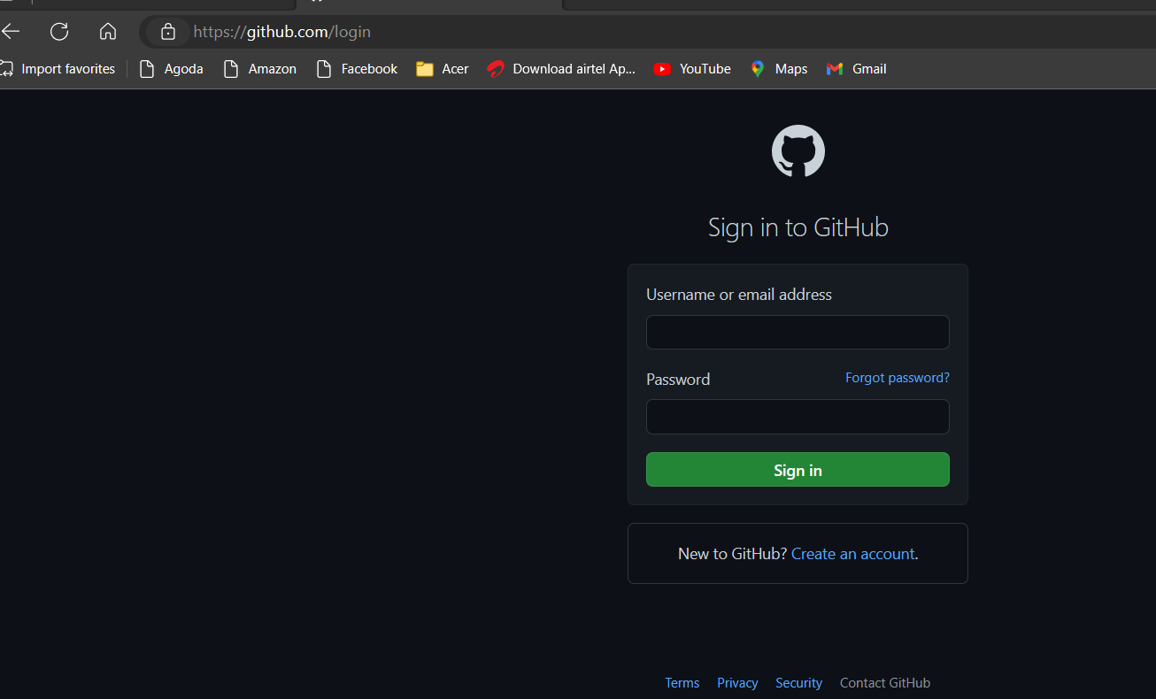

1. Enter Email and password

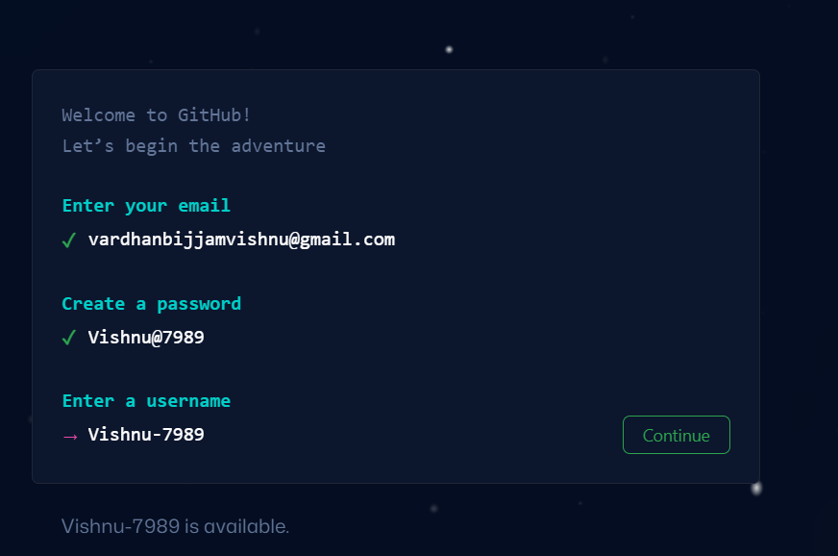

1. Click on “Continue”

* Create a repository
* Add files in it using ‘add files’ button
* Commit the changes

-------------------------------- :::::::::::::::::::::::::::: ---------------------------

1. What is repository
2. What is Branch
3. What is merging
4. What is Pull request
5. Commit
6. Push
7. Pull
8. Fetch